DOCUMENT 21 — 3D Visualization Library & Scene Protocol
Visionary Internal · v1.0 · VATS Layer 5 as a product surface

The most visible differentiator: the student manipulates the concept while the AGI
narrates it. Synchronization IS the product — a desynced voiceover is a broken teacher.

1. Library (concept → scene; ≥1 manipulable parameter each)

Concept | Scene | Control
Electron orbitals | probability cloud | sliders n, l, m
Newton's laws | rigid-body collision | mass ratio, initial velocity
Wave interference | parametric superposition | frequency, amplitude, phase
Mitosis | animated cell mesh | phase progression
DNA replication | helix unwinding | polymerase animation
Projectile motion | Cannon-es physics | angle, velocity
Chemical bonding | VSEPR geometry builder | rotate in 3D
Digestive system | labelled cross-section | click any organ

Coverage gate: 100% of JEE Physics + Chemistry syllabus at launch.

2. Stack & delivery
Three.js r168 (WebGL, no install) · Cannon-es physics · glTF 2.0 + Draco (~80% smaller)
· Cloudflare R2 + CDN edge cache · LOD auto-downgrade on low-end devices ·
2D SVG fallback per concept when WebGL unavailable or device <3GB RAM.

3. Scene protocol (AI ↔ visual sync)
LLM emits [SCENE:action,params] tokens inline in the response stream; the client
WebSocket listener dispatches them; narration timestamps cue renders (e.g. at 4.2s).

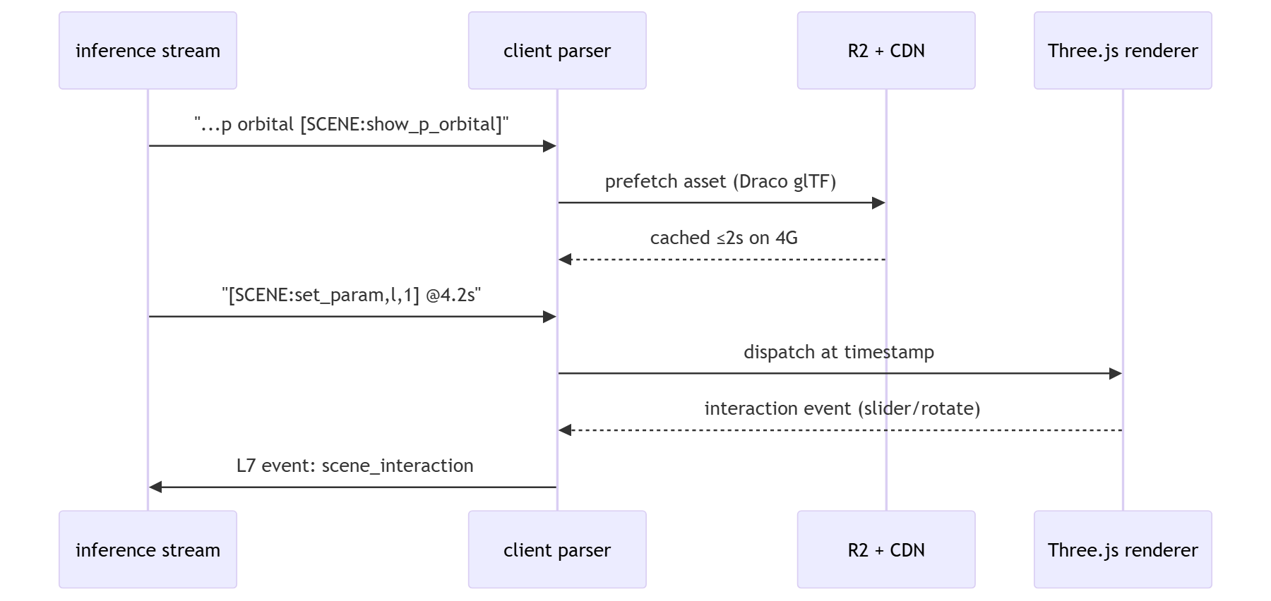

4. Performance contract
30fps on ₹8,000 Android / 4G — non-negotiable (R8) · first frame ≤1.5s · asset load
≤2s via Draco+LOD+CDN · zero independent voiceover (sync only) · user-driven motion
(no auto-spin; reduced-motion keeps a static labelled frame + text alternative).

OKF (VATS L5 carried verbatim)
KF1 30fps Redmi-class · KF2 100% JEE Phy+Chem coverage at launch · KF3 ≥1 manipulable
parameter per scene · KF4 temporal sync, zero independent voiceover · KF5 asset ≤2s on 4G.

